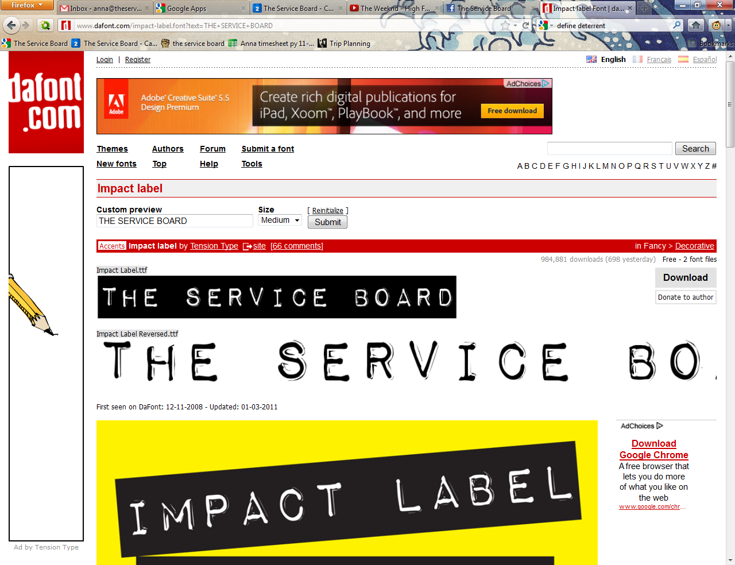
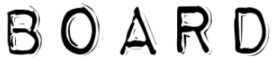
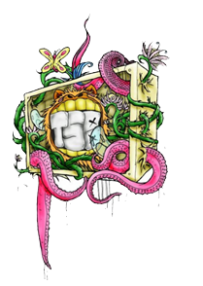

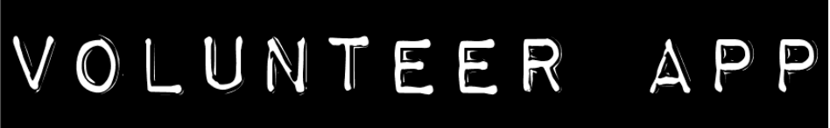

Send me to:
4408 Delridge Way SW, Seattle, WA 98106 • info@theserviceboard.org • fax: 206.324.6516
Name: Nickname (opt): Date of birth:
Ethnicity (opt): Preferred Gender Pronoun:
Number: Email:
Street Address:
City: State: Zip:
Short Q&A:
How did you hear about tSB?
Why do you want to volunteer with us?
What does “empowerment” mean to you?
Are you multi-lingual? What languages and how proficient are you?
What is a dish you like to cook?
Have you ever snowboarded? What’s your skill level?
Do you have any hidden talents (auto repair, graphic design, yoga, turntables, fundraising) that could be valuable to tSB?


What are your volunteer interests?
Food Boss: Are you an Iron Chef? You provide the skills and time, we’ll provide the food!
Project Partner: Chaperone and join in on our bi-weekly service projects. This is an awesome way to interact with youth!
Snowboarding Instructor: Are you comfortable enough to teach? You don’t have to be a grand-master snowboarder, just knowing the basics is enough to teach the newbies!
Graphics Designer: Everyone loves stickaz! tSB is notorious for its awesomely designed logos, and we’re always looking to the community for more. If you have an idea, or can help us bring one to life, we would love to collaborate!
Negotiate!: Lets work together with the tSB Volunteer Coordinator to design a mutually beneficial volunteer position!
Two Unrelated References
Name: Phone:
Name: Phone:



